# GOVERNMENT POLYTECHNIC COLLEGE MATTANNUR-670702

### (Department of Technical Education, Kerala)

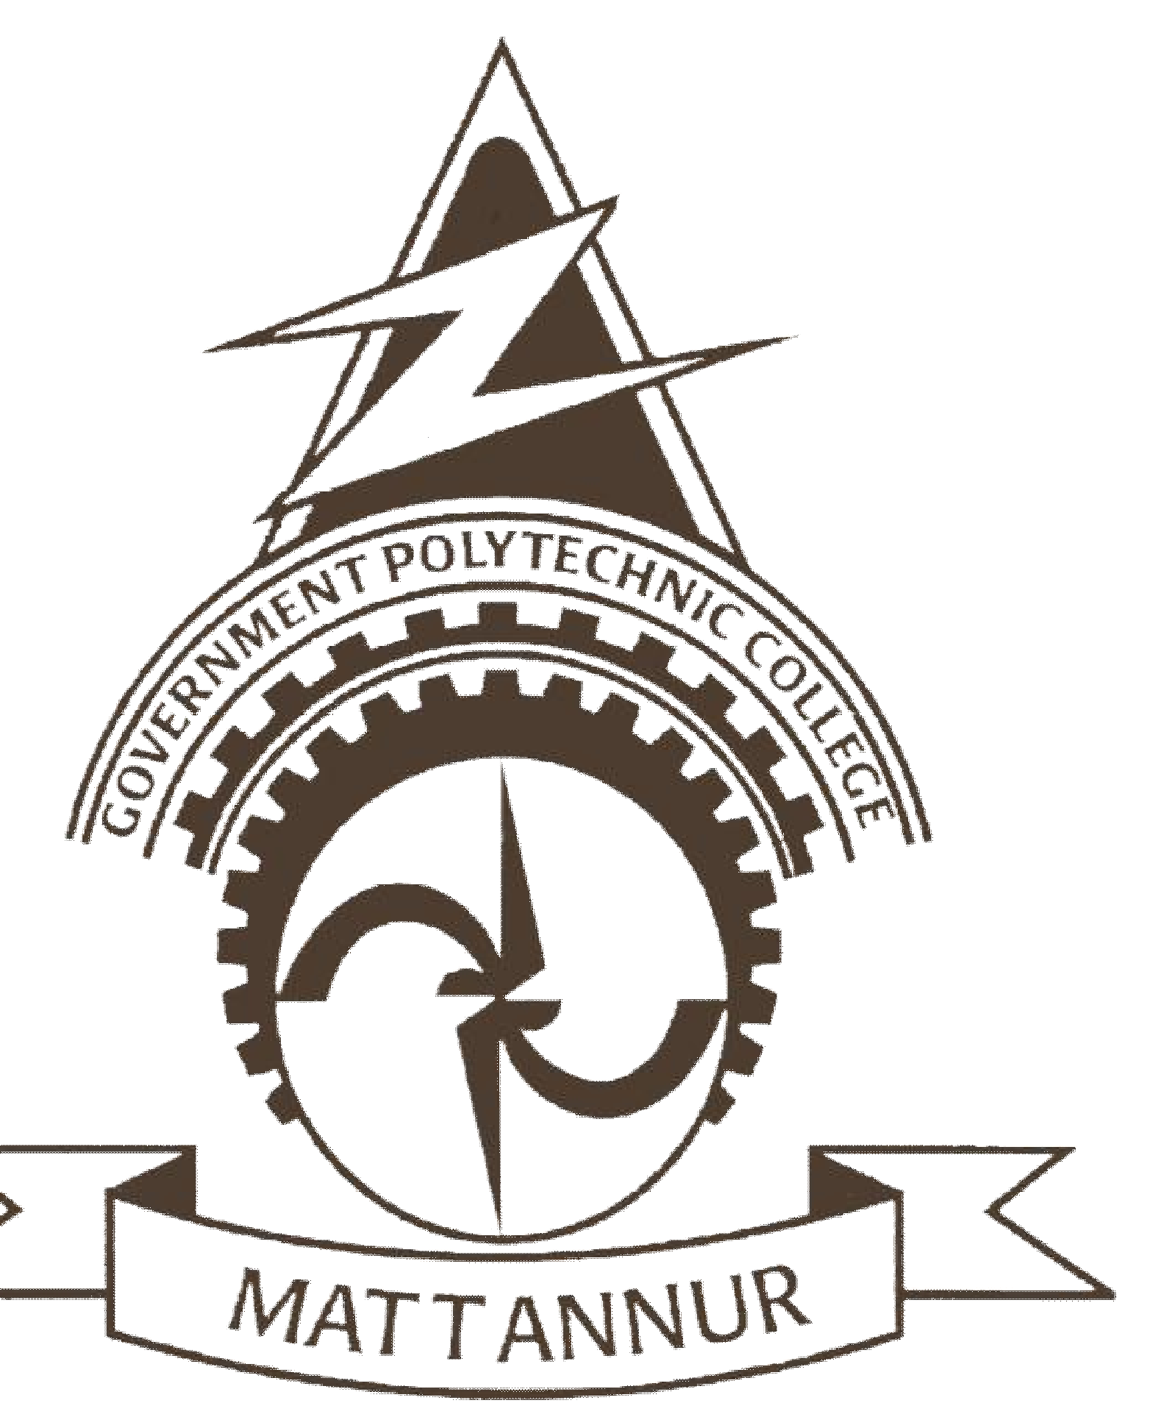

**SEMINAR REPORT ON**

**3D HOLOGRAPHIC PROJECTION TECHNOLOGY**

**SUBMITTED BY SURAS K**

**(Reg.No:19041682)**

**DEPARTMENT OF ELECTRONICS ENGINEERING**

**2021-22**

**GOVERNMENT POLYTECHNIC COLLEGE MATTANNUR-670702**

**(Department of Technical Education, Kerala)**

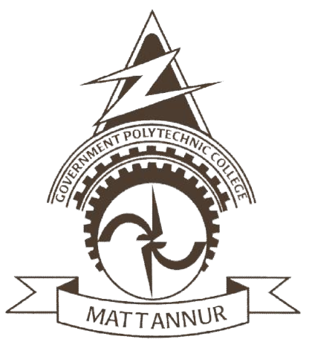

**CERTIFICATE**

*Certified that seminar work entitled* “***3D HOLOGRAPHIC PROJECTION TECHNOLOGY*”***is a bonafide work carried out by* **“*SURAS K* ”** *in partial fulfilment for the award of Diploma in Electronics Engineering from Government Polytechnic College Mattannur during the academic year* 2021-2022.

### Seminar Co-ordinator Head of Section

**Internal Examiner External Examiner**

**DECLARATION**

I hereby declare that the report of *the* ***3D HOLOGRAPHIC PROJECTION TECHNOLOGGY*** work entitled which is being submitted to the Govt. Polytechnic College Mattannur, in partial fulfilment of the requirement for the award **of *Diploma in Electronics Engineering*** *i*s a confide report of the work carried out by me. The material in this report has not been submitted to any institute for the award of any degree.

Place:Mattannur **SURAS K**

### ACKNOWLEDGEMENT

I would like to take this opportunity to extend my sincere thanks to people who helped me to make this seminar possible. This seminar will be incomplete without mentioning all the people who helped me to make itreal.

Firstly, I would like to thank GOD, almighty, our supreme guide, for bestowing his blessings upon me in my entire endeavor.

I would like to express my deepest gratitude **Mr. M C PRAKASHAN** (Principal GPTC, Mattannur), **Mr. GEORGE KUTTY P P (**Head of Department of Electronics Engg.), for the help rendered by him to prepare and present this Seminar in proper way. Moreover I am very much indebted to **Mr. SREEJITH A** (Lecturer, Electronics Engg, seminar co-ordinator), for their advice.

I am also indebted to all my friends and classmates who have given valuable suggestion and encouragement.

**SURAS K**

**ABSTRACT**

This seminar examines the new technology of Holographic Projections. It highlights the importance and need of this technology and how it represents the new wave in the future of technology and communications, the different application of the technology, the fields of life it will dramatically affect including business, education, telecommunication and healthcare. The paper also discusses the future of holographic technology and how it will prevail in the coming years highlighting how it will also affect and reshape many other fields of life, technologies and businesses. Holography is a diffraction-based coherent imaging technique in which a complex three-dimensional object can be reproduced from a flat, two-dimensional screen with a complex transparency representing amplitude and phase values. It is commonly agreed that real-time holography is the ne plus ultra art and science of visualizing fast temporally changing 3-D scenes. The integration of the real-time or electro-holographic principle into display technology is one of the most promising but also challenging developments for the future consumer display and TV market. Only holography allows the reconstruction of natural-looking 3-D scenes, and therefore provides observers with a completely comfortable viewing experience. But to date several challenges have prevented the technology from becoming commercialized. But those obstacles are now starting to be overcome. Recently, we have developed a novel approach to real-time display holography by combining an overlapping sub-hologram technique with a tracked viewing-window technology

TABLE OF CONTENTS

**CHAPTERNO TOPICS PAGENO**

Chapter1 INTRODUCTION……………………………………...8

Chapter2 3D HOLOGRAPHIC TECHNOLOGY…………….….9

Chapter2.1 HOLOGRAMS………………………………………....9

Chapter2.2 TYPES OF HOLOGRAMS……………………….……9

Chapter3 WORKING OF HOLOGRAM……………………..….12

Chapter3.1 REFLECTION HOLOGRAMS…………………….....13

Chapter4 ADVANCES IN HOLOGRAM TECHNOLOGY..…..19

Chapter4.1 TOUCHABLE HOLOGRAMS…………………….....19

Chapter4.2 TACTILE DISPLAY WITH HAPTIC FEEDBACK………..………………….………….…..19

Chapter4.3 USER INTERFACING INTEGRATED DISPLAY….19

Chapter4.4 360-DEGREE 3D SYSTEM……………………..…...19

Chapter5 ADVANTAGES……………………..….………….…20

Chapter6 DISADVANTAGES…………………………………..21

Chapter7 CONCLUSION………………………………………..22

Chapter8 REFERENCES………………………………..……….23

|  |  |  |
| --- | --- | --- |
| **FIGURE NO** | **LIST OF FIGURES**  **NAME** | **PAGE NO** |
| Fig 3.1 | RECORDING OF REFLEXES HOLOGRAMS……………………………….. | 13 |
| Fig 3.2 | IMAGE RECORDING…………………...……….. | 14 |
| Fig 3.3 | IMAGE RECONSTRUCTION……………..…….. | 15 |
| Fig 3.4  Fig 3.5  Fig 3.6  Fig 3.7 | IMAGE RECORDING……………………………  IMAGE RECONSTRUCTION……………………  IMAGE RECONSTRUCTION, PRIMARY IMAGE……………………………………………  IMAGE RECONSTRUCTION, SECONDARY IMAGE……………………………………………. | 16  17  17  18 |

**CHAPTER 1**

**INTRODUCTION**

Holographic projection is the new wave of technology that will change how we view things in the new era. It will have tremendous effects on all fields of life including business, education, science, art and healthcare. To understand how a holographic projector works we need to know what a hologram is. Holography is the method we use to record patterns of light. These patterns are reproduced as a threedimensional image called a hologram. While Hungarian physicist Dennis Gabor invented the hologram in 1947. Today’s new technology provides some outstanding advantages to not only everyday consumers but also large business corporations and governments.

Three-dimensional holographic projection technology is loosely based on an illusionary technique called Peppers Ghost, and was first used in Victorian theatres across London in the 1860s. Pepper's Ghost was typically used to create ghostlike figures on stage. Hidden from the audience's view, an actor dressed in a ghostly costume would stand facing an angled plate of glass. The audience would be able to see the glass, but not the actor directly. 3D holographic projection is a rapidly growing technology. With every business desperately trying to get their product to stand out from the competitors,

3D hologram advertising and promotion is fast becoming an eye catching success. Thanks to the latest in HD projection and CGI technology, 3D holographic projection has transformed itself from its basic Victorian origins into a futuristic audio visual display used by the likes of Endemol (Big Brother), Coco-Cola and BMW. With almost limitless holographic possibilities, from life like humans to blockbuster style special effects, as well as the continual advances in technology, 3D holographic projection has a bright future ahead

**CHAPTER 2**

**3D HOLOGRAPHIC TECHNOLOGY**

Holography is a diffraction-based coherent imaging technique in which a complex three-dimensional object can be reproduced from a flat, two-dimensional screen with a complex transparency representing amplitude and phase values. It is commonly agreed that real-time holography is the ne plus ultra art and science of visualizing fast temporally changing 3-D scenes. The integration of the real-time or electro-holographic principle into display technology is one of the most promising but also challenging developments for the future consumer display and TV market. Only holography allows the reconstruction of natural-looking 3-D scenes, and therefore provides observers with a completely comfortable viewing experience. A holoprojector will use holographic technology to project large-scale, high-resolution images onto a variety of different surfaces, at different focal distances, from a relatively small-scale projection device. To understand the technology used in holographic projection, we must understand the term ‘Hologram’, and the process of making and projecting holograms. Holography is a technique that allows the light scattered from an object to be recorded and later reconstructed. The technique to optically store, retrieve, and process information. The holograms preserve the 3-D information of a holographed subject, which helps to project 3D images.

**2.1 Holograms**

A hologram is a physical component or device that stores information about the holographic image. For example a hologram can be a grating recorded on a piece of film. It is especially useful to be able to record a full image of an object in a short exposure if the object or space changes in time. Holos means “whole” and graphein means “writing”. Holography is a technique that is used to display objects or scenes in three dimensions. These 3D images are called holograms. A photographic record produced by illuminating the object with coherent light (as from a laser) and, without using lenses, exposing a film to light reflected from this object and to a direct beam of coherent light. When interference patterns on the film are illuminated by the coherent light a three-dimensional image is produced

**2.2 Types of holograms**

A hologram is a recording in a two-or three-dimensional medium of the interference pattern formed when a point source of light (the reference beam) of fixed wavelength encounters light of the same fixed wavelength arriving from an object (the object beam). When the hologram is illuminated by the reference beam alone, the diffraction pattern recreates the wave fronts of light from the original object. Thus, the viewer sees an image indistinguishable from the original object.

There are many types of holograms, and there are varying ways of classifying them. For our purpose, we can divide them into three types: reflection hologram, transmission holograms and computer generated holograms.

A. The reflection hologram :- The reflection hologram, in which a truly three-dimensional image is seen near its surface, is the most common type shown in galleries. The hologram is illuminated by a “spot” of white incandescent light, held at a specific angle and distance and located on the viewer’s side of the hologram. Thus, the image consists of light reflected by the hologram. Recently, these holograms have been made and displayed in colour—their images optically indistinguishable from the original objects. If a mirror is the object, the holographic image of the mirror reflects white light .

B. Transmission holograms :- The typical transmission hologram is viewed with laser light, usually of the same type used to make the recording. This light is directed from behind the hologram and the image is transmitted to the observer’s side. The virtual image can be very sharp and deep. Furthermore, if an undiverged laser beam is directed backward (relative to the direction of the reference beam) through the hologram, a real image can be projected onto a screen located at the original position of the object.

C. Computer Generated Holograms :- Computer Generated Holography (CGH) is the method of digitally generating holographic interference patterns. A holographic image can be generated e.g. by digitally computing a holographic interference pattern and printing it onto a mask or film for subsequent illumination by suitable coherent light source. Alternatively, the holographic image can be brought to life by a holographic 3D display (a display which operates on the basis of interference of coherent light), bypassing the need of having to fabricate a "hardcopy" of the holographic interference pattern each time. Consequently, in recent times the term "computer generated holography" is increasingly being used to denote the whole process chain of synthetically preparing holographic light wavefronts suitable for observation. Computer generated holograms have the advantage that the objects which one wants to show do not have to possess any physical reality at all (completely synthetic hologram generation). On the other hand, if holographic data of existing objects is generated optically, but digitally recorded and processed, and brought to display subsequently, this is termed CGH as well

**CHAPTER 3**

**WORKING OF HOLOGRAM**

The time-varying light field of a scene with all its physical properties is to be recorded and then regenerated. Hence the working of holography is divided into two phases:

1. Recording

2. Reconstruction

Recording of hologram: Basic tools required to make a hologram includes a red lasers, lenses, beam splitter, mirrors and holographic film. Holograms are recorded in darker environment, this is to avoid the noise interference caused by other light sources.

The recording of hologram is based on the phenomenon of interference. It requires a laser source, a plane mirror or beam splitter, an object and a photographic plate. A laser beam from the laser source is incident on a plane mirror or beam splitter. As the name suggests, the function of the beam splitter is to split the laser beam. One part of splitted beam, after reflection from the beam splitter, strikes on the photographic plate. This beam is called reference beam. While other part of splitted beam (transmitted from beam splitter) strikes on the photographic plate after suffering reflection from the various points of object. This beam is called object beam.

The object beam reflected from the object interferes with the reference beam when both the beams reach the photographic plate. The superposition of these two beams produces an interference pattern (in the form of dark and bright fringes) and this pattern is recorded on the photographic plate. The photographic plate with recorded interference pattern is called hologram. Photographic plate is also known as Gabor zone plate in honour of Denis Gabor who developed the phenomenon of holography.

Each and every part of the hologram receives light from various points of the object. Thus, even if hologram is broken into parts, each part is capable of reconstructing the whole object.

There are two basic types of holograms:

• Reflection holograms

• Transmission holograms

1 Reflection holograms form images by reflecting a beam of light off the surface of the hologram. This type of hologram produces very high quality images but is very expensive to create.

2 Transmission holograms form images by transmitting a beam of light through the hologram. This type of hologram is more commonly seen since they can be inexpensively mass-produced. Embossed holograms, such as those found on credit cards, are transmission holograms with a mirrored backing.

**3.1 Reflection Holograms**

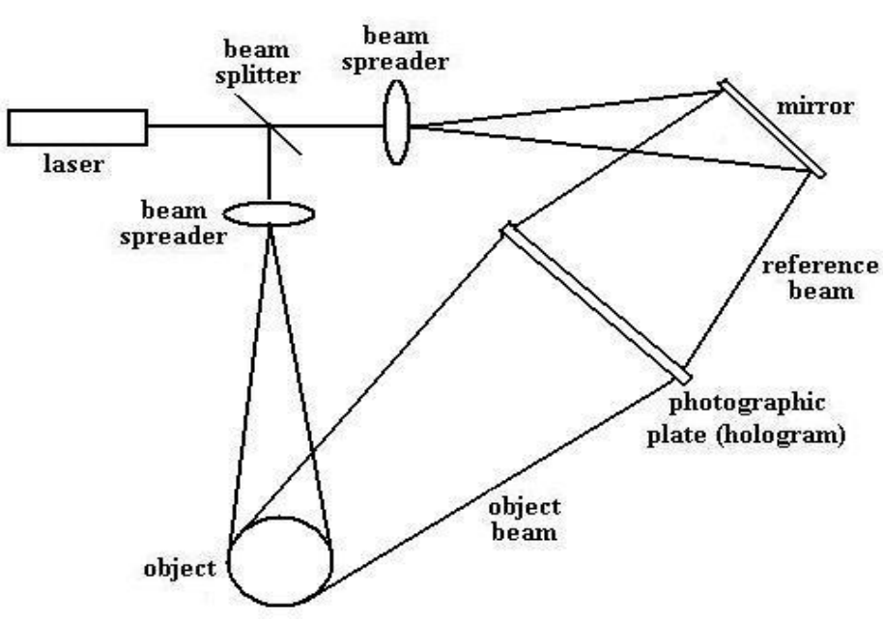

Fig 3.1 Recording of reflexes holograms

(a) Recording Reflection Holograms

• The laser provides a highly coherent source of light. The beam of light hits the beam splitter, which is a semi-reflecting plate that splits the beam into two: an object beam and a reference beam.

• The object beam is widened by a beam spreader (expanding lens) and the light is reflected off the object and is projected onto the photographic plate.

• The reference beam is also widened by a beam spreader and the light reflects off a mirror and shines on the photographic plate.

• The reference and object beams meet at the photographic plate and create the interference pattern that records the amplitude and phase of the resultant wave.

(b) Reconstructing Reflection Holograms

• A reconstruction beam of light is used to reconstruct the object wave front. The reconstruction beam is positioned at the same angle as the illuminating beam that was used during the recording phase.

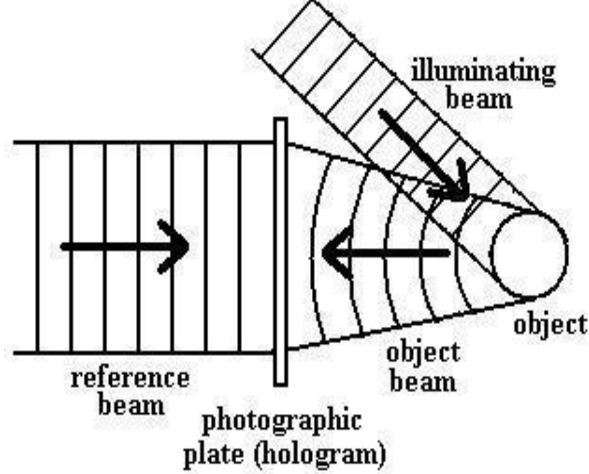

Fig 3.2 Image recording

• The virtual image appears behind the hologram at the same position as the object

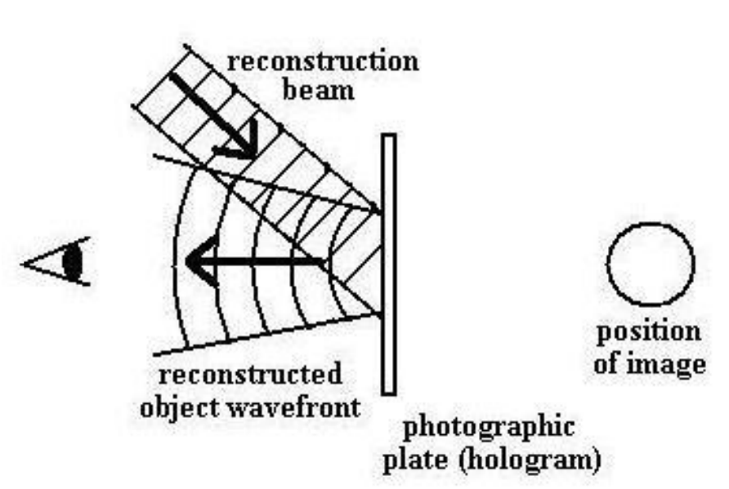

Fig 3.3 Image reconstruction

(ii) Transmission Holograms

1. Recording Transmission Holograms

• As with reflection holograms, a laser is used to provide a highly coherent source of light. A beam splitter and beam spreaders are also used in the recording of transmission holograms.

• After the object beam passes through the beam spreader, the light is reflected off a mirror and onto the object. The object beam is then reflected onto the photographic plate.

• The reference beam is also reflected off a mirror and shines on the photographic plate.

• The incoming object and reference beams create a resultant wave. The amplitude and phase of the resultant wave is recorded onto the photographic plate as an interference pattern.

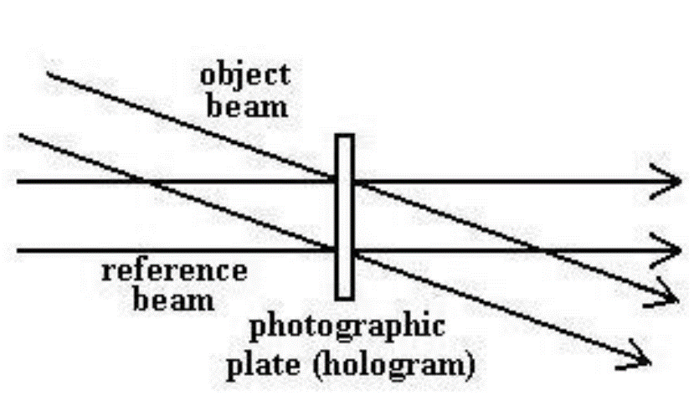

Fig 3.4 Image recording

1. Reconstructing Transmission Holograms

• A reconstruction beam is used to illuminate the hologram and is positioned at the same angle as the reference beam that was used during the recording phase.

• When the reconstruction beam is placed at the right angle, three beams of light will pass through the hologram:

• An undiffracted beam (zeroth order) will pass directly through the hologram but will not produce an image.

• A second beam forms the primary (virtual) image (first order) that is diffracted at the same angle as the incoming object beam that was used during recording.

• A third beam forms the secondary (real) image (first order).

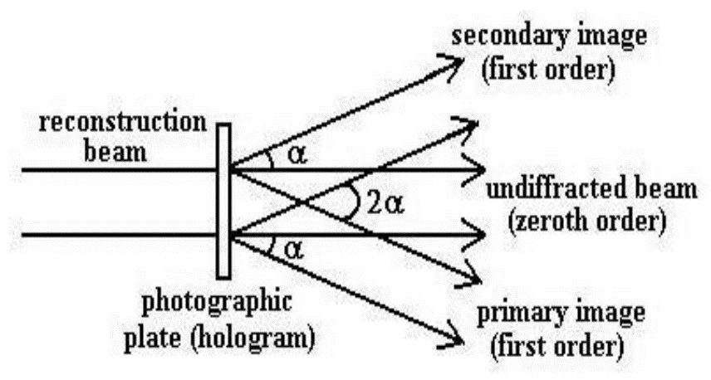

Fig 3.5 Image reconstruction

• As we can see in the diagram, the beams that form the images are diffracted at the same angle, α, from the undiffracted beam. Between the image beams, the angle is twice as large, or 2α. • If we look at the hologram at the same angle as the primary image beam (also same angle as recording object beam), we will see a virtual image of the object located behind the hologram.

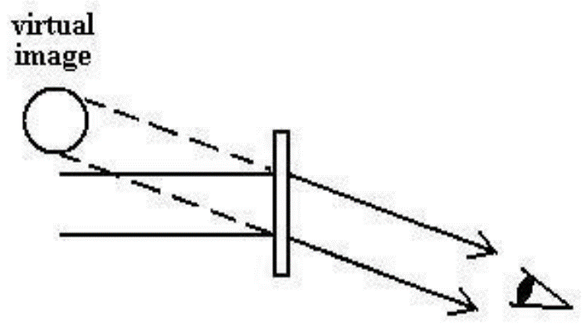

Fig 3.6 Image reconstruction, primary image

• If we look at the hologram at the same angle as the secondary image beam, we will see a real image of the object located in front of the hologram.

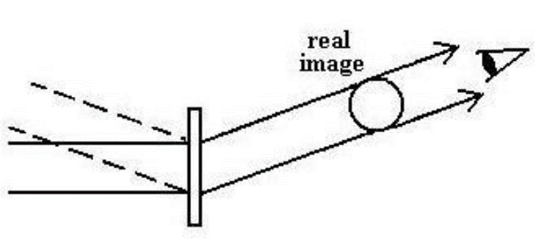

Fig 3.7 Image reconstruction, secondary image

**CHAPTER 4**

**ADVANCES IN HOLOGRAPHIC TECHNOLOGY**

**4.1 Touchable holograms**

The importance of haptic interaction techniques gather much more attention with the progress of the computer graphics, the physical simulation and the visual display technologies. There have been a lot of interactive systems which aim to enable the users to handle 3D graphic objects with their hands. If tactile feedback is provided to the user’s hands in 3D free space, the usability of those systems will be considerably improved. One strategy to provide tactile feedback in 3D free space is to attach tactile displays on the user’s hands.

The method is based on a nonlinear phenomenon of ultrasound; acoustic radiation pressure. When an object interrupts the propagation of ultrasound, a pressure field is exerted on the surface of the object. This pressure is called acoustic radiation pressure.

**4.2 Tactile display with haptic feedback**

“Airborne Ultrasound Tactile Display [Iwamoto et al. 2008]” is a tactile display which provides tactile sensation onto the user’s hand. It utilizes the nonlinear phenomenon of ultrasound; acoustic radiation pressure. When an object interrupts the propagation of ultra-sound, a pressure field is exerted on the surface of the object.

**4.3 User interfacing integrated displays**

While camera-based and marker-less hand tracking systems are demonstrated these days, we use Wiimote (Nintendo) which has an infrared (IR) camera for simplicity. A retro reflective marker is attached on the tip of user’s middle finger. IR LEDs illuminate the marker and two Wiimotes sense the 3D position of the finger. Owing to this hand-tracking system, the users can handle the floating virtual image with their hands.

**4.4 360-degree 3D system**

The system was made possible by projecting high-speed video on a spinning mirror. As the spinning mirror changes direction, different perspectives of the projected image is shown. The University of Southern California project is more realistic compared to other holographic attempt because, nearly 5, 000 individual images are reflected every second.

**CHAPTER 5**

**ADVANTAGES**

The interest in 3D viewing is not new. The public has embraced this experience since at least the days of stereoscopes, at the turn of the last century. New excitement, interest, and enthusiasm then came with the 3D movie craze in the middle of the last century, followed by the fascinations of holography, and most recently the advent of virtual reality. Recent developments in computers and computer graphics have made spatial 3D images more practical and accessible. Modern three-dimensional (”3D”) display technologies are increasingly popular and practical not only in computer graphics, but in other diverse environments and technologies as well. A concurrent continuing need is for such practical autostereoscopic 3D displays that can also accommodate multiple viewers independently and simultaneously. A particular advantage would be afforded if the need could be fulfilled to provide such simultaneous viewing in which each viewer could be presented with a uniquely customized autostereoscopic 3D image that could be entirely different from that being viewed simultaneously by any of the other viewers present, all within the same viewing environment, and all with complete freedom of movement therein. A high resolution three dimensional recording of an object. Another feature is that these are glasses free 3D display. This 3D technology can accommodate multiple viewers independently and simultaneously, which is an advantage no other 3D technology can show. The 3D holographic technology does not need a projection screen. The projections are projected into midair, so the limitations of screen are not applicable for 3D holographic display

**CHAPTER 6**

**DISADVANTAGES**

* It has higher production cost compare to 2D projection.
* It is not easily seen in the presence of fluorescent lighting.
* Use of applying the concept of holographic projection in the design of products are costly.
* It is time consuming to construct images using 3D holograms.
* Holographic data storage suffers from noise and sensitivity issues. Moreover it has material limitations.

**CHAPTER 7**

**CONCLUSION**

Holography may still be in its infant stage, but its potentials applications are aspiring. Holographic Technology and Spectral Imagining has endless applications, as far as the human mind can imagine. Holography being the closest display technology to our real environment may just be the right substitute when reality fails. With holography, educational institutions may become a global village sooner that people thought, where information and expertise are within reach. Knowledge sharing and mobility will only cost a second and learning will become more captivating and interactive. First, there is an urgent need to address the infrastructural deficiencies limiting the application of holography in education.

More interestingly, the display medium of holography is very important. A 360 viewing angle is especially what is needed to maximize the use of holography in education. Being able to display a 3D hologram in free air is also vital, because interacting with holograms in a covered display may be cumbersome. In order not to limit the use of holography to a non-interactive display medium, incorporation with feedback technologies is mandatory. The haptic technology which makes it possible to touch and manipulate virtual object is especially important. As the field of haptics continues to grow and integrates with holography, interaction with holograms becomes limitless. In future, holographic displays will be replacing all present displays in all sizes, from small phone screen to large projectors

**CHAPTER 8**

**REFERNCES**

1. Ahmed Elmorshidy, Ph.D ; “Holographic Projection Technology: The World is Changing.”; JOURNAL OF TELECOMMUNICATIONS, VOLUME

2. ISSUE 2, MAY 2010 2. Thomas J. Naughton; “Capture, processing, and display of real-world 3D objects using digital holography”; 2010 IEEE Invited Paper

3. Takayuki Hoshi, Masafumi Takahashi, Kei Nakatsuma; “Touchable Holography”; The University of Tokyo; 2009

4. Stephan Reichelt, Ralf Haussler, Norbert Leister, Gerald Futterer, Hagen Stolle and Armin Schwerdtner; “Holographic 3-D Displays - Electro-holography within the Grasp of Commercialization”; Advances in Lasers and Electro Optics